CURRICULM VITAE

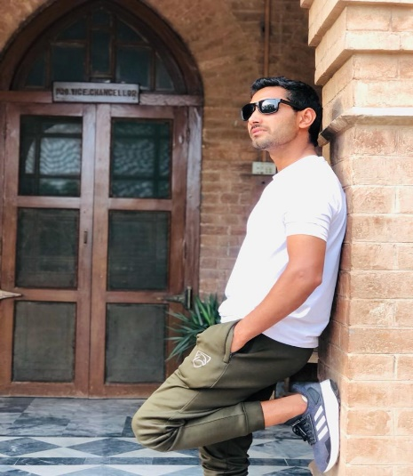

Daud Khan
Strength and conditioning Coach
Email: kdaudkhan0313@gmail.com

Objective:

Seeking a challenging role as a fitness trainer where I can combine my knowledge of anatomy with practical experience in developing effective workout plans for individuals or groups. To use my passion for health and fitness to create innovative training programs that will maximize results while minimizing risk of injury.

Academic Qualification

Level | Institution
SSC | Government High School Police Colony Nasir Bagh Road Peshawar
F. Sc (Computer Science) | Islamia College Peshawar
BS (Pakistan Studies). Continued… | Islamia College university Peshawar
- Level Two strength and conditioning Coach (PSCA)

- Level 2 rehabilitation physio (PSCA)

- National Athlete

Professional Fitness Experience

Sports Experience at School Level:
- Captain of cricket Team GHS Police Colony Peshawar
- Attend Scout Camp at Abbottabad

Sports Experience at College Level:
- Athlete of Islamia College Peshawar
- Member of the Cross Country of Islamia College Peshawar

Inter board Level:
- Player of the Athletics team of Peshawar board
- Member of the Cross-Country team of Peshawar

Sports Experience at University Level:
- Athlete of Islamia University.

________________________________________________________________
AWARDS:
- Certificate of Athletics from Islamia College Peshawar (2019-20)
- Certificate of Player of the cross country of Islamia college Peshawar (2018)
- Certificate of player of the cross country of Islamia College Peshawar (2019)
- Certificate of the player of Athletics of Islamia College Peshawar
- Certificate of All Pakistan Inter Board (Athletics Competition)
- Certificate of Cricket Team from GHS Police Colony Peshawar
- Certificate of Cricket Team from Islamia Collage University Peshawar
________________________________________________________________

Fitness Experience:
- Fitness Experience with team at National Level:
Trainer with Tribal Lion Team in KP Hockey league
- Fitness experience at Academy Level:
Trainer in ICA (Islamia Cricket Academy)
- Fitness Experience at gym Level:
Trainer in Zalmi Fitness gym (Police Colony)
Trainer in Shaheen run for life gym
- Fitness experience with National and International players
Personal Trainer of Fakhar Zaman (International Cricket Player of Pakistan Cricket)
Personal Trainer of Usman Shanwari (International Cricket Player of Pakistan Cricket)
Personal trainer of current Pakistan hockey team player Hammad Anjum
Personal trainer of Pakistan Hockey team player Rana Waheed
Personal trainer of Pakistan Hockey team player Afraz Ahmad
Personal trainer of Junior Pakistan Hockey team player Adeel
Personal trainer of Afghanistan National cricket player Tahir Adil
Personal trainer of Pakistan first class player Umar Islam
Personal trainer of Agriculture sports director Bilal Marwat
Personal trainer of ICA director Qazi Shafiq Lala

Personal Trainer of Pakistan first class player Nasir Ahmad
Also train local and provincial players

References:
- Zakir Khan Sports Director of RMI and Trainer of Lahore Qalandar Cricket Team and Personal Trainer of Shaheen Shah Afridi
- Mr. Qazi Shafiq Lala Director of Islamia Cricket Academy
- Mr. Bilal Marwat Director of Sports Agriculture University Peshawar

